Activity title:
Colonial Flags
Teacher name:  Aaron Hall, Mike Gornichec, and Kayleen Henderson | Grade level(s):  5th Grade
Time required to complete this activity:
Five half hour sessions
Overall Activity Design
Content area standard(s) and supporting performance indicator(s) | 3a. Identify the 21st c. skills students will practice in this project. Select several applicable performance indicators from at least 2 of the ISTE National Education Technology Standards for Students (NETS*S)  Creativity and Innovation  b.create original works as a means of personal or group expression.  Communication and Collaboration  b. communicate information and ideas effectively to multiple audiences using a variety of media and formats.  c. develop cultural understanding and global awareness by engaging with learners of other cultures.  Research and Information Fluency  c. evaluate and select information sources and digital tools based on the appropriateness to specific tasks.  4. Critical Thinking, Problem Solving, and Decision Making  b. plan and manage activities to develop a solution or complete a project.  5. Digital Citizenship  a. advocate and practice safe, legal, and responsible use of information and technology. b. exhibit a positive attitude toward using technology that supports collaboration, learning, and productivity. c. demonstrate personal responsibility for lifelong learning. d. exhibit leadership for digital citizenship.  6. Technology Operations and Concepts  c. troubleshoot systems and applications.  3b. State your criteria for exemplary performance in each. What would success look like?  Success would be when the student demonstrates a strong knowledge of historical importance’s used on state or national flags and how those symbols represent the historical beliefs which laid the foundation for each state individually. They would have to demonstrate this with their research and with their groups final digital project (their flags with symbols and their definitions of what each symbol implies). Along with their project, the student must express themselves and their heritage into the flag, as well as still being able to incorporate their group members as well.  The entire project must be done using a variety of digital media and digital manipulations.
Pedagogy | Students will study the symbols found on various state flags around the US or World. They will connect the historical symbolism and infer why each state chose these specific symbols to represent their state. Students will create their own colonial flag which would parallel the creation of our nation with the original 13 colonies. This project will drive the idea of the importance of how symbolism, historical events, and each students’ personal heritage intertwine together to shape our unique country.
Technology | Personal tablets with internet access, any screen casting app (I use Explain Everything), and Pages app to take notes on.
Level(s) of Bloom’s Revised Taxonomy | Covers the Digital Taxonomy of higher order thinking from remembering to creating.
Materials | Personal tablets with internet access, any screen casting app (I use Explain Everything), and Pages app to take notes on.
Activity Objective | Students will study the symbols found on various state flags around the US or World. They will connect the historical symbolism and infer why each state chose these specific symbols to represent their state. Students will create their own colonial flag which would parallel the creation of our nation with the original 13 colonies.
How the teacher uses technology | Promethean board and flags of the U.S. app will be used to introduce the symbolism found in the various U.S. flags, and the importance of the direct symbolism being used.
How the students use technology | Success would be when the student demonstrates a strong knowledge of historical importance’s used on state or national flags and how those symbols represent the historical beliefs which laid the foundation for each state individually. They would have to demonstrate this with their research and with their groups final digital project (their flags with symbols and their definitions of what each symbol implies). Along with their project, the student must express themselves and their heritage into the flag, as well as still being able to incorporate their group members as well.  The entire project must be done using a variety of digital media and digital manipulations.
Classroom management techniques | The first challenge is that I need to better tie down the loose ends of this project. I feel I have left many gaps embedded in it. I will need to better prepare my students and my expectations for the project.  Another would be that the students will be struggling to be in control of the final design. I probably should have each one produce a project using the same symbols and have the students choose which product would be the final entry. This part would be hard for the students to choose.
Preparation before class | Start with the introduction of the students expressing their own family heritage and the expression of seeking out their genealogy. Students love to learn about themselves and where they came from. Also, it will require them to seek outside assistance from parents and relatives to learn of their family history. Once students have had an opportunity to express their personal heritage they will then be able find a relationship between their history and their state or national history. Then in turn may be able to relate the symbols found in their familiar backgrounds and relate them to the symbols found on national and state flags. They can relate this to the understanding that each state has a history and their family’s heritage may have played a role in that symbolism.
Activity Specifics
Activity description | - Students will seek out their genealogy and present their findings with written expression.  - Students will seek out any symbols that their family may have traditionally passed down from generation to generation.  - Students will study the symbolism found in flags at the local, state, and national level.  - Students will decipher the meaning of a flag of their choice and present their findings. Students may find some related symbolism in the flags that may relate to their families heritage.  - Students will be grouped up and be asked to take apart in the creation of their own colony. Each colony needs to have a flag which represents the people who founded the colony, so each member is to be represented in the group’s flag. The flag must be made using their choice of digital media. They are to seek out or create their own symbol which represents them and that can be placed on the flag with their groups symbols. The flag must be aesthetically pleasing and look professional.  - Students are to present their flags to the class with definitions of each symbol and what they signify.
Assessment | Individual written reflection: Students need to have time to reflect on what is being learned. They need to express any emotion they may feel during this learning process especially when it comes to learning new facts about themselves or family members.  Individual evaluations: Students should have a say in their grades. They know the effort and contribution they have made regarding the processes of the project and their opinions should be expressed when it comes to their grade.
Link to sample (teacher or student generated): Couldn’t get link to screen cast to work so here is my example.
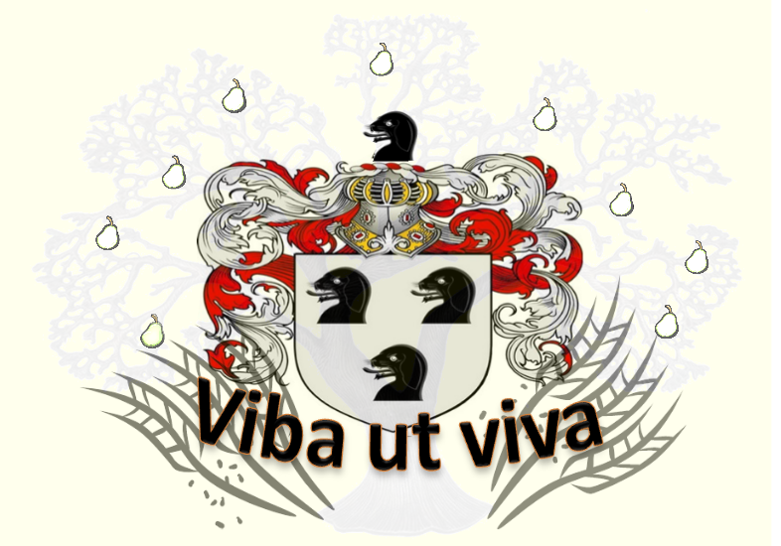
Students will present and state what each symbol means and their importance to their heritage.

